CSS: Concepts and Practical Exercises
Types of CSS, syntax, selectors, the box model, and three worked tasks

1. Types of CSS

Inline CSS
Written directly on an element using the style attribute. It has the highest priority but is hard to maintain since styling is scattered through the HTML.
<p style="color: blue; font-size: 18px;">This is inline CSS.</p>

Internal CSS
Written inside a <style> tag in the <head> of the document. Applies only to that one page.
<head>
<style>
p { color: green; }
</style>
</head>

External CSS
Written in a separate .css file and linked with <link>. Best for real projects — one stylesheet can style many pages, and the HTML stays clean.
<link rel="stylesheet" href="style.css">

2. CSS Syntax
Every CSS rule has the same shape: a selector followed by a declaration block of property/value pairs.
selector {
property: value;
property: value;
}

h1 {
color: navy;
font-size: 32px;
}
h1 is the selector (what gets styled). Each "property: value;" pair is a declaration, and the group of declarations inside { } is the declaration block.

3. CSS Selectors
Selectors decide which elements a rule applies to. Classes can be reused on many elements; IDs must be unique, one per page.
Selector | Syntax | Example
Element | tag | p { color: black; }
Class | .name | .highlight { background: yellow; }
ID | #name | #main-title { font-size: 40px; }
Universal | * | * { margin: 0; }
Descendant | a b | div p { color: gray; }

4. The CSS Box Model
Every HTML element is a rectangular box made of four layers, from the inside out: content, padding, border, and margin.
div {
width: 200px;
padding: 20px;
border: 5px solid black;
margin: 10px;
}
That div's total rendered width is 200 + 20+20 (padding) + 5+5 (border) + 10+10 (margin) = 290px, unless box-sizing: border-box is set, which forces width to include padding and border instead of adding to them.

Task 1: Student Profile — All Three CSS Types
index.html uses inline CSS (on the name and programme lines), internal CSS (the <style> block controlling the heading's color, size and alignment), and external CSS (style.css, controlling the card layout, page background and the description box).
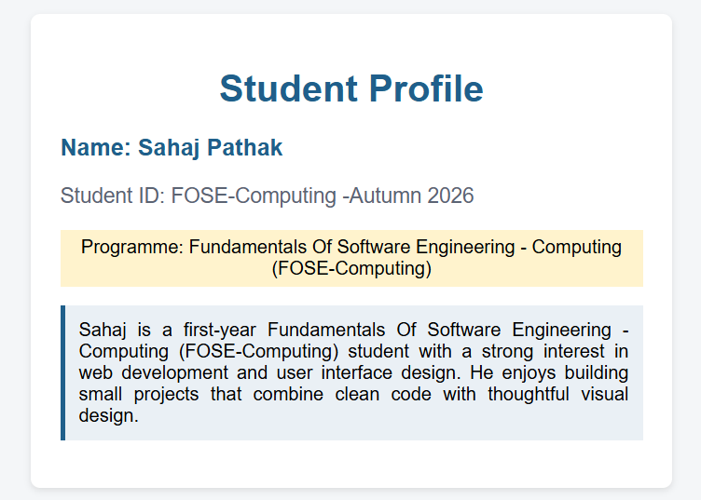
Figure 1: Rendered output of Task 1 (index.html + style.css)

Key external CSS (style.css)
.profile-card {
background-color: white;
max-width: 500px;
margin: 0 auto;
padding: 25px;
border-radius: 8px;
box-shadow: 0 2px 6px rgba(0,0,0,0.1);
}

.description {
background-color: #eaf0f5;
padding: 12px;
text-align: justify;
border-left: 4px solid #1f5f8b;
}

Task 2: Three Divs — Element, Class and ID Selectors
The element selector (div) sets the shared border, padding, margin, height and width on all three boxes. The second div adds a class selector (.highlight-box) for its background, text color, bold weight and centering. The third div adds an id selector (#special-box) for its unique background color, rounded corners and right-aligned text.
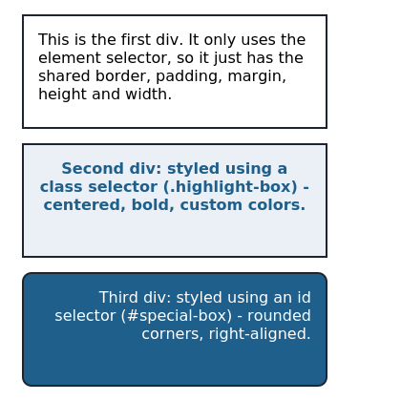
Figure 2: Rendered output of Task 2 (index.html + style.css)
div {
border: 2px solid #1d2330;
padding: 15px;
margin: 15px;
height: 120px;
width: 320px;
}

.highlight-box { background-color: #eaf0f5; color: #1f5f8b;
font-weight: bold; text-align: center; }

#special-box { background-color: #1f5f8b; color: white;
border-radius: 10px; text-align: right; }

Task 3: index.html + style.css — Heading, Paragraph, Image, Skills List
The heading is centered, recolored and resized. The whole page uses one font-family. The paragraph's line-height is increased for readability, and the skills list is styled using a class selector (.skills-list).
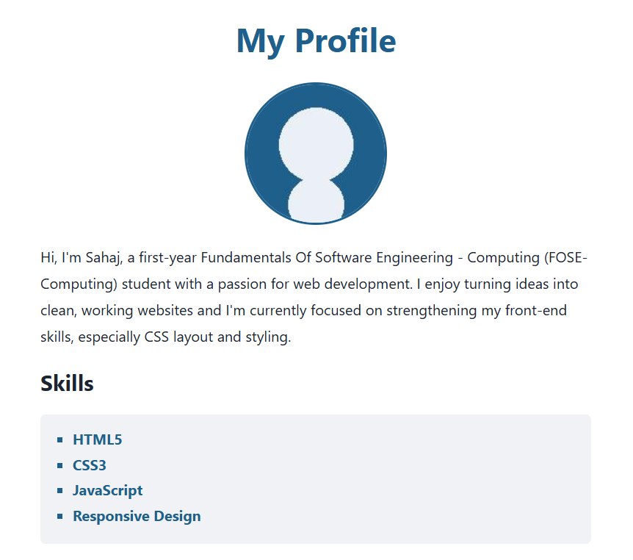
Figure 3: Rendered output of Task 3 (index.html + style.css)
h1 { color: #1f5f8b; font-size: 36px; text-align: center; }
body { font-family: 'Segoe UI', Arial, sans-serif; }
.profile-text { line-height: 1.8; font-size: 16px; }

.skills-list {
list-style-type: square;
background-color: #f0f2f5;
padding: 15px 15px 15px 35px;
border-radius: 6px;
}

